Root Server

🌍 What is a Root Server in DNS?
# Source: Chatgpt (GPT-5-Mini) at [1/18/2026]
A Root Server is the first step in translating (resolving) a human-readable domain name (like www.example.com) into an IP address that computers can use.
🧠 Think of it as the "master index" of the internet’s Domain Name System (DNS).

🔁 DNS Lookup Process (Where the Root Server Fits)
# Source: Chatgpt (GPT-5-Mini) at [1/18/2026]
When you try to visit a website:
- Your device asks a Recursive Resolver for the IP of www.example.com.
- The resolver checks its cache. If it doesn't know the answer, it asks a:
- ✅ Root Server: "Where can I find .com domain info?"
- The root server responds: "Ask a TLD Server for .com domains."
- The resolver then goes to the TLD Server, which sends it to the Authoritative DNS Server for example.com.
- The IP address is returned to your device.

🧱 Root Server = The DNS Starting Point
# Source: Chatgpt (GPT-5-Mini) at [1/18/2026]
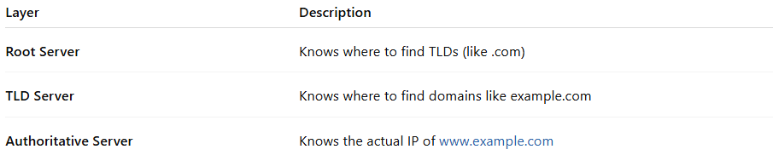

Layer in DNS | Description
Root Server | Knows where to find TLDs (like .com)
TLD Server | Knows where to find domains like example.com
Authoritative Server | Knows the actual IP of www.example.com

🌐 How Many Root Servers Exist?
# Source: Chatgpt (GPT-5-Mini) at [1/18/2026]
There are 13 main root server IP addresses, labeled A–M (e.g., A.root-servers.net, B.root-servers.net, etc.).
But thanks to Anycast, there are over 1,000 physical root server instances around the world to handle DNS traffic quickly and reliably.

🔐 Root Server Facts
# Source: Chatgpt (GPT-5-Mini) at [1/18/2026]
- Managed by different organizations (e.g., Verisign, ICANN, NASA).
- Use UDP port 53 (or TCP 53 for larger queries).
- Provide information about top-level domains (TLDs) like .com, .org, .net, .uk, etc.
- Do not contain information about individual websites.

✅ Summary
# Source: Chatgpt (GPT-5-Mini) at [1/18/2026]
Root Server = The first helper in DNS resolution
🗂️ Knows where to find TLDs like .com, .org
🔁 Works with recursive resolvers
🌐 Globally distributed via Anycast
⚡ Foundation of the internet’s domain name system

